ASSIGNMENT-3

1. Write java Program for Consider a scenario, Bank is a class that provides functionality to get rate of interest. But, rate of

interest varies according to banks. For example, SBI, ICICI and AXIS banks could provide 8%,

7% and 9% rate of interest.(Method Overriding)

CODING:

class Bank {

float getRateOfInterest() {

return 0.0f;

}

}

class SBI extends Bank {

@Override

float getRateOfInterest() {

return 8.0f;

}

}

class ICICI extends Bank {

@Override

float getRateOfInterest() {

return 7.0f;

}

}

class AXIS extends Bank {

@Override

float getRateOfInterest() {

return 9.0f;

}

}

public class Main {

public static void main(String[] args) {

Bank sbi = new SBI();

Bank icici = new ICICI();

Bank axis = new AXIS();

System.out.println("SBI Rate of Interest: " + sbi.getRateOfInterest() + "%");

System.out.println("ICICI Rate of Interest: " + icici.getRateOfInterest() + "%");

System.out.println("AXIS Rate of Interest: " + axis.getRateOfInterest() + "%");

}

}

OUTPUT:

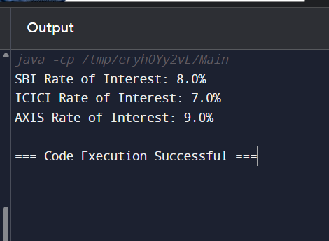

2. . Develop a JAVA code to display the balance. Include the following members:

• Design a class to represent a bank account.

• Data Members: Name of the depositor, Account number, Type of account(Savings/Current), Balance amount in the account(Minimum balance is Rs.500.00)

• Methods:

1. To read account number, Depositor name, Type of account.

2. To deposit an amount (Deposited amount should be added with it)

3. To withdraw an amount after checking balance(Minimum balance must be Rs.500.00

Note : Assume that balance amount = 10000

Test Cases

1. 100, Raja, S, 8000

2. Raja, 100, S, 9000

3. 101, Rani, S, 12000

4. 102, Ragu, W, 8000

5. 103, Ravi, C, 10000

CODING:

class BankAccount {

private String depositorName;

private int accountNumber;

private String accountType;

private double balance;

public BankAccount(String depositorName, int accountNumber, String accountType, double balance) {

this.depositorName = depositorName;

this.accountNumber = accountNumber;

this.accountType = accountType;

this.balance = balance >= 500 ? balance : 500;

}

public void displayAccountDetails() {

System.out.println("Account Number: " + accountNumber);

System.out.println("Depositor Name: " + depositorName);

System.out.println("Account Type: " + accountType);

System.out.println("Balance: " + balance);

}

public void deposit(double amount) {

if (amount > 0) {

balance += amount;

System.out.println("Amount deposited: " + amount);

System.out.println("New balance: " + balance);

} else {

System.out.println("Invalid deposit amount");

}

}

public void withdraw(double amount) {

if (amount > 0 && balance - amount >= 500) {

balance -= amount;

System.out.println("Amount withdrawn: " + amount);

System.out.println("New balance: " + balance);

} else if (amount <= 0) {

System.out.println("Invalid withdrawal amount");

} else {

System.out.println("Insufficient balance to maintain minimum balance of Rs.500");

}

}

public static void main(String[] args) {

BankAccount account1 = new BankAccount("Raja", 100, "S", 8000);

account1.displayAccountDetails();

account1.deposit(1000);

account1.withdraw(9000);

BankAccount account2 = new BankAccount("Rani", 101, "S", 12000);

account2.displayAccountDetails();

account2.deposit(2000);

account2.withdraw(5000);

BankAccount account3 = new BankAccount("Ragu", 102, "W", 8000);

account3.displayAccountDetails();

account3.deposit(500);

account3.withdraw(8500);

BankAccount account4 = new BankAccount("Ravi", 103, "C", 10000);

account4.displayAccountDetails();

account4.deposit(500);

account4.withdraw(2000);

}

}

OUTPUT:

